Evidence (Road Map Explorer).
Header:
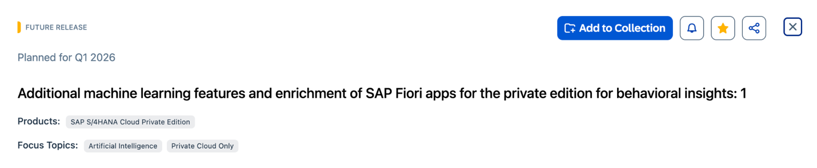
Overview:
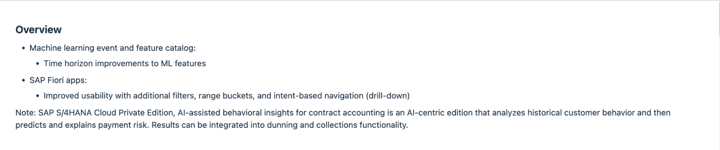
Benefits:
